# **Name: Abdurrahman Qureshi**

# **Roll No: 210451**

Practical No: 6

**1)Do Compatibility Testing on a Web Page.**

**MAIN ASPECT:**

**The Web Page should be able to change its size and design but keep its functionality according to the viewport of the end user that is the user’s device.**

**The web page should be responsive and interactive even in small and large devices.**

**SPECIFICATIONS:**

* Performing the Browser Compatibility
* Performing the Mobile Compatibility
* Performing the Navigation testing
* Checking menu and buttons for their navigational functionality.
* Check for duplicates values in database.
* Check for updating and deletion in database.
* Performing the Web Server Testing
* Performing the Application Server Testing

**REQUIREMENTS:**

* Responsive Design
* Easy to navigate-through UI
* Change according to user’s device

**OUTPUT:**

**Mobile:**

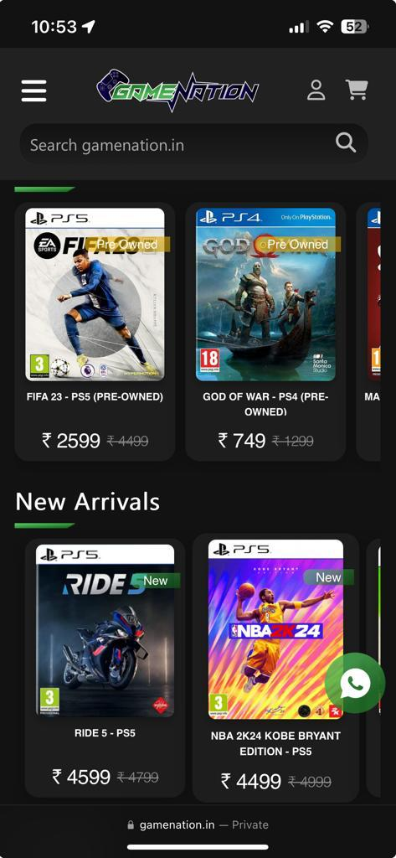

**PC:**

